Howard Husky Apparel Sale!

HPSA is offering another opportunity to purchase Howard Elementary apparel!

The sale starts Wednesday, March 2nd and order forms are due Thursday, March 17th. Orders will be sent home with your student when we return from Spring Break! The items available are the same items that were offered in the fall with a few additions. Apparel can be seen on display at school, outside the gym doors.
Make checks payable to HPSA.
A  Hooded Sweatshirt  Available in Royal Blue or Grey  Size S, M, or L  Adult: $18  Child: $17  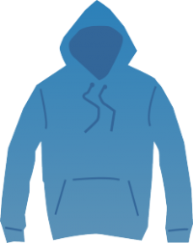 | B  Long Sleeve Shirt  Available in Royal Blue or Grey  Size S, M, or L  Adult: $15  Child: $14  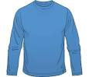 | C  Short Sleeve Shirt  Available in Royal Blue or Grey  Size S, M, or L  Adult: $11  Child: $10  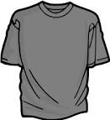
D  Baseball Hat  Royal Blue  Adult: $10  Child: $10  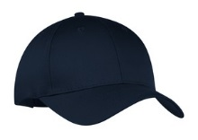 | E  Cinch Bags  Royal Blue  $6  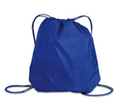 | F  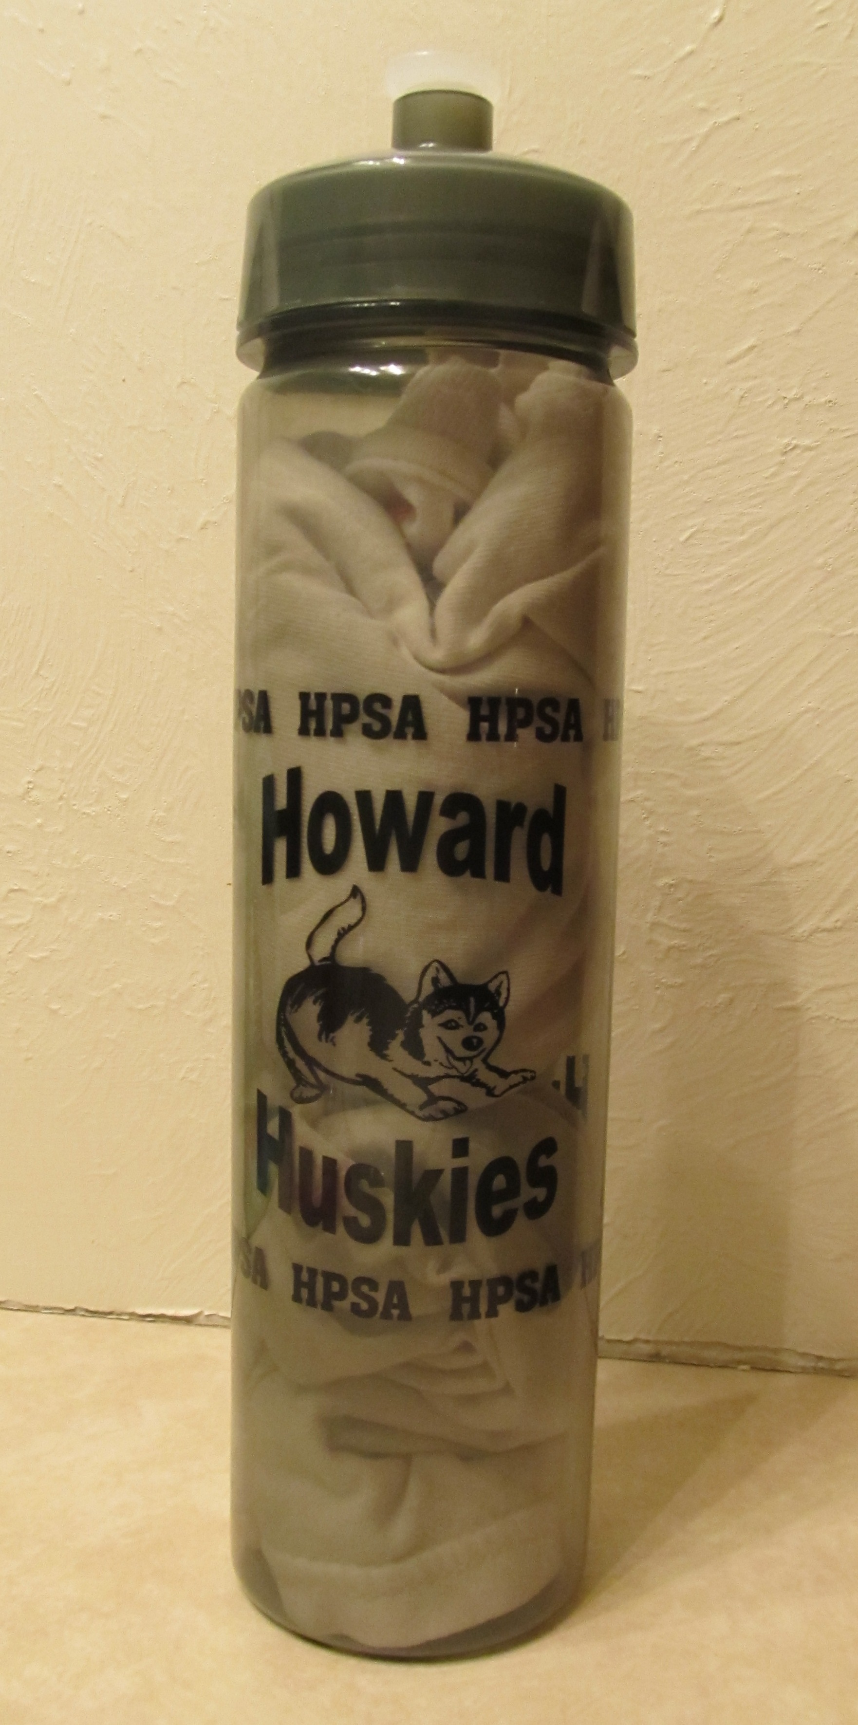  Water Bottle  Grey  $3
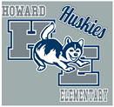
Husky Logo Used
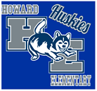
Husky Logo Used
Student’s Name:_____________________________________________
Grade:________________ Teacher:_____________________________
Parent’s Name: ______________________________________________
Phone #: _____________________________

Item # | Description | Qty | Color | Adult/Child | Size | Total
A | Example Item Order | 1 | Royal Blue | Child | L | 17.00
 |  |  |  | Total Amount Due:

Please return this order form & money to school no later than Thursday March 17th. Thank you!

