Well Enough? | Stay Home  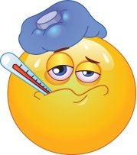 | Good to Go!
Fever | If your child has a temperature of 100.4°F | When your child is fever-free for 24 hours (without fever reducing medications like Tylenol)
Vomiting | If your child has vomited in the last 24 hours | When vomiting stops and your child can hold food/water down
Diarrhea | If your child has diarrhea more than three times a day or if it is watery | When there is no diarrhea for 24 hours
Pinkeye | If the eye is stuck, bright red, oozing yellow or green discharge | When your child has been on antibiotic eye drops for at least 24 hours
Strep Throat | If your child has a confirmed case of strep throat | When your child has been on antibiotics for 24 hours
Cough/Sore Throat | If your child has an achy throat, swollen glands, a headache or stomachache | When symptoms improve
How to Prevent Illnesses
- Wash hands or use hand sanitizer to clean your hands of any germs
- Cover your cough or sneeze with your elbow or tissue to stop the spread of illness
- Get plenty of rest, water and eat a healthy diet to boost your immune system
- Stay home when you are sick to help prevent the spread of illness
- Clean surfaces like doorknobs, counters, toys, light switches to clean them of any germs
- Avoid touching your eyes, mouth and nose as that is how germs get into your body.

